Mata Kuliah | : | Pengolahan Citra dan Visi Komputer
Program Studi | : | D4 – Teknik Informatika
Semester | : | 5
Kelas | : | TI 3C
NIM | : | 244107020240
Nama | : | Mochammad Rijal Dzaki Rifki Afifudin
Praktikum Ke- | : | 1

Laporan Praktikum

- D1. Pengenalan Github dan Google Colab
Langkah | Jawaban/Deskripsi
1 | Membuat Reposistory Github untuk matakuliah PCVK:  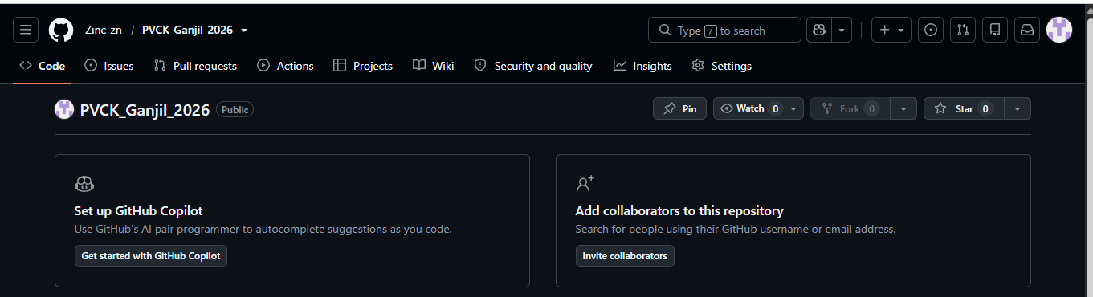
2 | Meng-integrasi google collab dan github  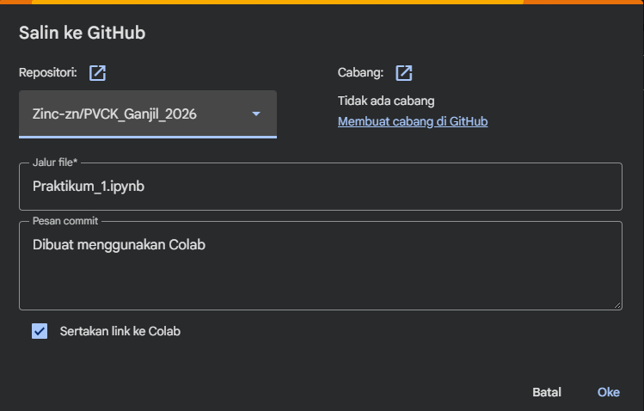  Hasil setelah integrase:  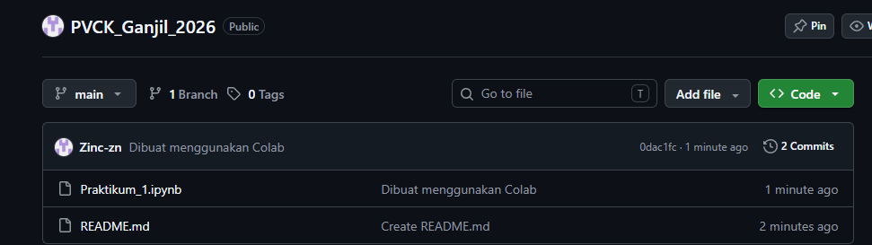
3 | Mengganti nama file:  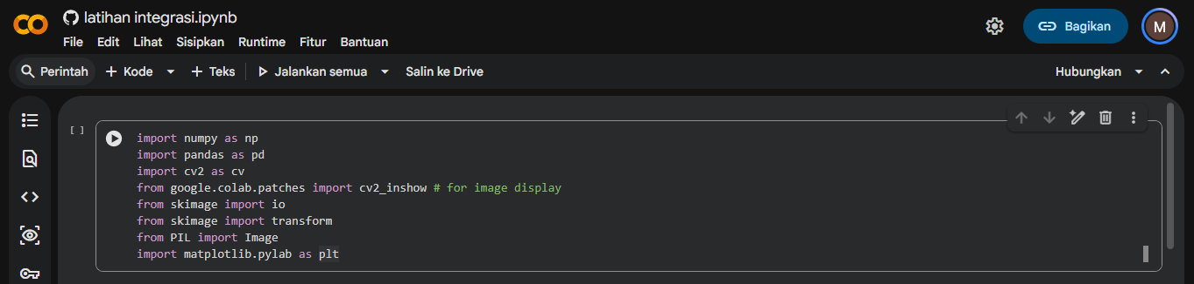

- D2. Pengenalan Python untuk membaca dan menampilkan image dengan pengenalan macam-macam Library (Numpy, pandas, cv2, skimage, PIL dan matplotlib)
Langkah | Jawaban/Deskripsi
1 | Library:  import numpy as np  import pandas as pd  import cv2 as cv  from google.colab.patches import cv2_inshow # for image display  from skimage import io  from skimage import transform  from PIL import Image  import matplotlib.pylab as plt
2 | Membaca dan menampilkan image:  Code:  # Membuat list untuk menyimpan url dari beberapa image  urls = ["https://iiif.lib.ncsu.edu/iiif/0052574/full/800,/0/default.jpg",  "https://iiif.lib.ncsu.edu/iiif/0016007/full/800,/0/default.jpg",  "https://encrypted-tbn0.gstatic.com/images?q=tbn:ANd9GcT5fFr3ADwcqt1B5ZN6_7Hl7HqwYCjKiLzxuNhpBqd8dw&s=10"]  # baca dan tampilkan image  # loop pada tiap url image, beberapa image dapat disimpan pada list  for url in urls:  image = io.imread(url) #read image  image = cv.resize(image, (0,0), fx=0.5, fy=0.5) #resize image to half size  image_2 = cv.cvtColor(image, cv.COLOR_BGR2RGB) #convert color to RGB  final_frame = cv.hconcat((image, image_2)) #concatenate image  cv2_imshow(final_frame) #show image  print('\n')  Hasil:  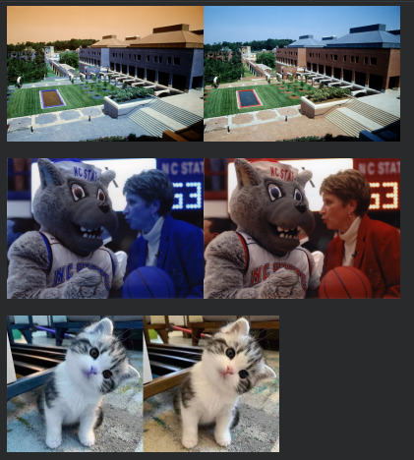
3 | Melihat ukuran file image:  Code:  tinggi = image_2.shape[0]  lebar = image_2.shape[1]  print("resolusi image: tinggi x lebar = ",tinggi," x ",lebar)  cv2_imshow(image_2)  Hasil:  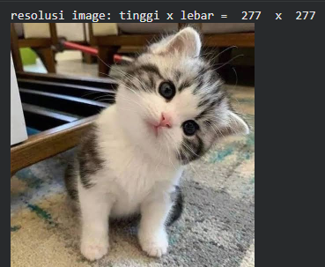
4 | Mengakses pixel dengan memberikan garis horizontal berwarna putih di tengah image:  Code:  image_2 = cv.cvtColor(image, cv.COLOR_BGR2RGB)  image_3 = cv.cvtColor(image, cv.COLOR_BGR2RGB)  #membuat garis horizontal ditengah image  for y in range (lebar):  image_3[int((tinggi)/2),y] = [255,255,255]  final_frame = cv.hconcat((image_2, image_3))  cv2_imshow(final_frame)  Hasil:  